**Assignment12.2**

* **Given a list of strings - List[String] (“alpha”, “gamma”, “omega”, “zeta”, “beta”)**

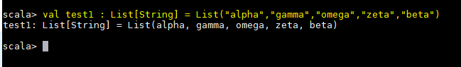

* **Find count of all strings with length 4**

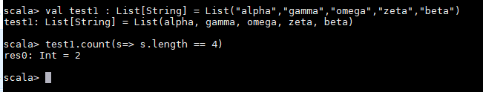

* **Convert the list of string to a list of integers, where each string is mapped to its**

**corresponding length.**

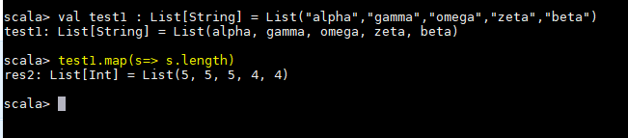

* **Find count of all strings which contain alphabet ‘m’**

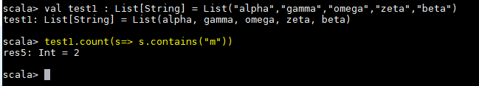

* **Find the count of all strings which start with the alphabet ‘a’**

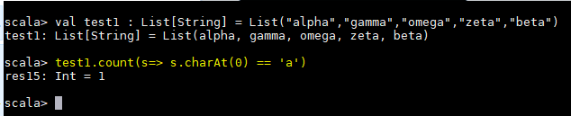

**\*\*\*\*\*\*\*\*\*\*\*\*\*\*\*\*\*\*\*\*\*\*\*\*\*\*\*\*\*\*\*END\*\*\*\*\*\*\*\*\*\*\*\*\*\*\*\*\*\*\*\*\*\*\*\*\*\*\*\*\*\*\*\*\*\*\*\*\*\*\*\*\*\*\*\*\*\*\*\*\*\***